Detailed Research on Amazon Web Services (AWS) and Google Cloud Platform (GCP) Products in regards to storage, computing and analytics.
By Yohannes Deboch , November 3, 2019
General Introduction
As we all know cloud computing is growing in an amazing speed and impacts most business and enterprises . Instead of struggling with complicated on-premise servers and networking various companies and enterprises are highly depending on cloud computing due to its cost-effectiveness, security and reliability . In this regard the major players in the cloud computing are Azure, Google Cloud, and AWS. In this research I will be focusing on comparing AWS and GCP by giving more emphasis on the storage, computing and analytics .
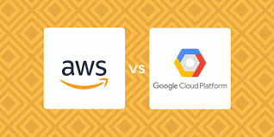

AWS Product List
Amazon Web Services (AWS) is a subsidiary of Amazon.com which launched to provide cloud computing services to businesses and individuals back in 2006. Amazon has definitely paved the way for cloud computing.
A few of their 200+ products include:
- Amazon Elastic Compute Cloud (Amazon EC2)
- AWS Elastic Beanstalk
- Amazon EC2 Container Service
- Amazon DynamoDB
- Amazon Redshift
- Amazon Lambda
- Amazon DynamoDB
- Amazon S3
- Amazon CloudFront
- Amazon Route 53

Google Cloud Platform Products
Google Cloud Platform is essentially made up of a lot of different services and solutions which allow you to utilize the same software and hardware infrastructure that Google uses for their own products, such as YouTube and Gmail. They launched their first service, Google App Engine in a public preview in 2008.
A few of their 50+ products include:
- Google Compute Engine
- Google App Engine
- Google Container Engine
- Google Cloud Bigtable
- Google BigQuery
- Google Cloud Functions
- Google Cloud Datastore
- Google Storage
- Google Cloud CDN
- Google Cloud DNS
GCP quick-start tutorials
Short tutorials Short tutorials to help you get started with Cloud Platform products, services, and APIs can be accessed from this link ( https://cloud.google.com/gcp/getting-started/#quick-starts).Screenshot of how the above quick start tutorial looks like is provided below .
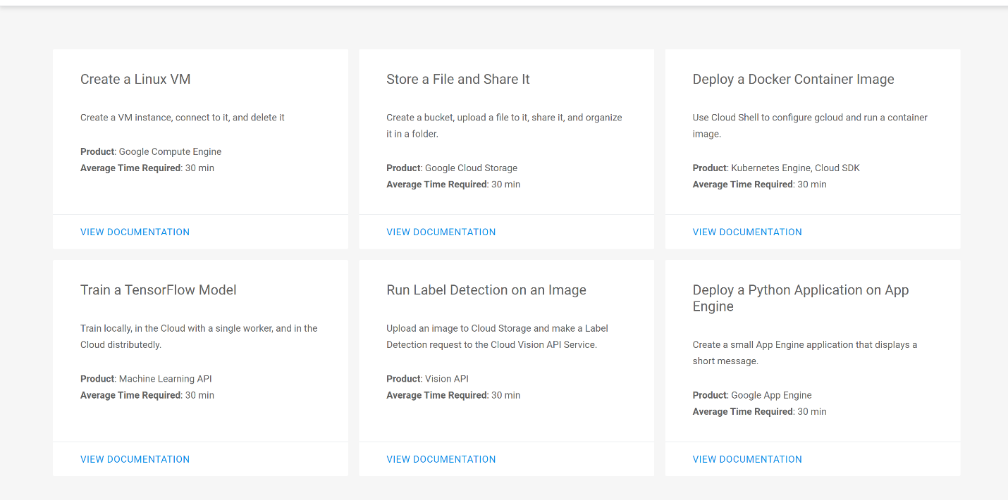
AWS quick-start tutorials
Quick Starts are built by AWS solutions architects and partners to help you deploy popular technologies on AWS, based on AWS best practices for security and high availability. These accelerators reduce hundreds of manual procedures into just a few steps, so you can build your production environment quickly and start using it immediately.
Each Quick Start includes AWS CloudFormation templates that automate the deployment and a guide that discusses the architecture and provides step-by-step deployment instructions. Detailed quick-start tutorials can be found on https://aws.amazon.com/quickstart/?quickstart-all.sort-by=item.additionalFields.updateDate&quickstart-all.sort-order=desc, (https://aws.amazon.com/gettingstarted/tutorials/)
Mapping GCP to AWS products
AWS services and AWS Marketplace solutions equip you to more effectively manage your business and data by enhancing decision making and enabling real-time action. AWS Marketplace is a digital catalog with thousands of listings from independent software vendors that enables you to find, test, buy, and deploy software that runs on AWS. More and more enterprise companies are migrating to the AWS Cloud and there are a number of reasons why. While every organization is going to have their own unique motivations, common drivers include exiting data centers, increasing business agility, improving workforce productivity, gaining transparency in operational costs and reducing risk.
The AWS Migration Acceleration Program (MAP) is designed to help enterprises that are committed to a migration journey achieve a range of these business benefits by migrating existing workloads to Amazon Web Services. MAP has been created to provide consulting support, training and services credits to reduce the risk of migrating to the cloud, build a strong operational foundation and help offset the initial cost of migrations. It includes a migration methodology for executing legacy migrations in a methodical way as well as robust set of tools to automate and accelerate common migration scenarios.
By migrating to AWS, enterprises will be able to focus on business innovation instead of dedicating time and attention to maintaining their existing systems and technical debt. Sacrifices and painful trade-offs no longer have to be made to get something to market quickly. Instead, enterprises can focus on differentiating their business in the marketplace and taking advantage of new capabilities.
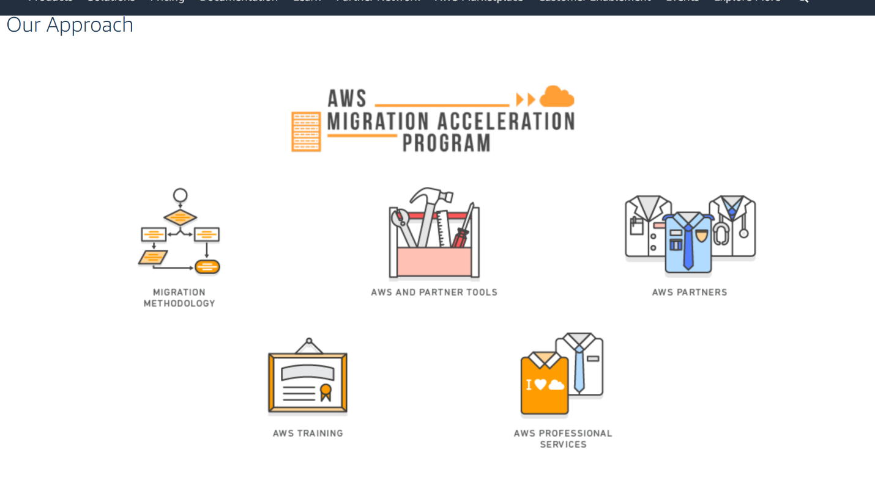

Mapping GCP to MS Azure
Azure and GCP each provide command-line interfaces (CLIs) for interacting with services and resources. Azure provides both the Azure CLI, which is a cross-platform tool, and a set of Azure PowerShell cmdlets that you can install and use through Windows PowerShell. GCP provides a set of command-line tools and PowerShell cmdlets through the Cloud SDK, a cross-platform toolkit.
Azure and GCP also provide web-based consoles. Each console allows users to create, manage, and monitor their resources.
Cloud platforms provide a set of core services: compute, storage, networking, and database services. Azure's core services include the following:
- Compute: Azure virtual machines, Azure App Service, Azure Kubernetes Service
- Storage: Azure Blob Storage, Azure Managed Disks
- Networking: Azure Virtual Network (VNet)
- Databases: Azure Cloud SQL Database, Azure SQL Data Warehouse, Azure Table Storage, CosmosDB
GCP's core services include the following:
- Compute: Compute Engine, App Engine, Google Kubernetes Engine
- Storage: Cloud Storage, Compute Engine persistent disks
- Networking: Virtual Private Cloud (VPC)
- Databases: Cloud SQL, Cloud Firestore, Cloud Bigtable, Cloud Spanner
Each platform then builds other offerings on top of these services. Typically, the higher-level services can be categorized as one of the following types:
- Application services: Services designed to help optimize applications in the cloud. Examples include Azure Service Bus and Google Cloud Pub/Sub.
- Big data and analytics, AI, and IoT services: Services designed to help process, interpret, and derive insights from large amounts of data, such as Azure HDInsight and Google Cloud Dataflow.
- Management services: Services designed to help you manage your application and track its performance. Examples include Azure Application Insights and Google Stackdriver Monitoring.
The following tables provide a side-by-side comparison of the services available on Azure and GCP.

Compute
Category | Azure | GCP
IaaS | Virtual Machines | Compute Engine
PaaS | App Service, Cloud Services | App Engine
Containers | Azure Kubernetes Service, Azure Service Fabric | Google Kubernetes Engine
Serverless functions | Azure Functions | Cloud Functions

Networking
Category | Azure | GCP
Virtual networks | Azure VNets | VPC
Load balancer | Azure Load Balancer, Application Gateway | Cloud Load Balancing
Dedicated interconnect | ExpressRoute | Cloud Interconnect
DNS | Azure DNS | Cloud DNS
CDN | Azure CDN | Cloud CDN

Storage
Category | Azure | GCP
Object storage | Azure Blob Storage | Cloud Storage
Block storage | Disk Storage | Persistent Disk
File storage | Azure File Storage | Cloud Filestore
Reduced-availability storage | Azure Cool Blob Storage | Cloud Storage Nearline
Archival storage | Azure Archive Blob Storage | Cloud Storage Coldline

Database
Category | Azure | GCP
RDBMS | SQL Database | Cloud SQL, Cloud Spanner
NoSQL: key-value | Table Storage | Cloud Firestore, Cloud Bigtable
NoSQL: indexed | Cosmos DB | Cloud Firestore

Big data and analytics
Category | Azure | GCP
Batch data processing | HDInsight, Batch | Cloud Dataproc, Cloud Dataflow
Stream data processing | Stream Analytics | Cloud Dataflow
Stream data ingestion | Event Hubs, Service Bus | Cloud Pub/Sub
Analytics | Data Lake Analytics, Data Lake Store | BigQuery

Application services
Category | Azure | GCP
Messaging | Service Bus, Storage Queues | Cloud Pub/Sub
API management | API Management | Apigee, Cloud Endpoints
Web firewall | Azure WAF | Google Cloud Armor
DDoS protection | Azure DDoS Protection | Google Cloud Armor
Caching | Azure Cache for Redis | Cloud Memorystore

Management services
Category | Azure | GCP
Monitoring | Application Insights | Monitoring
Logging | Log Analytics | Stackdriver Logging
Deployment | Azure Resource Manager | Cloud Deployment Manager

Artificial intelligence
Category | Azure | GCP
Auto-generated models | Automated Machine Learning | Cloud AutoML
Speech | Cognitive Services - Speech | Cloud Speech-to-Text
Vision | Cognitive Services - Computer Vision | AutoML Vision
Natural language processing | Cognitive Services - Language | Cloud Natural Language
Video intelligence | Video Indexer | Cloud Video Intelligence
Fully managed ML | Cognitive Services, Automated Machine Learning | AI Platform Prediction

IoT
Category | Azure | GCP
Managed IoT | Azure IoT Hub | Cloud IoT Core
IoT on Edge | Azure IoT Edge | Cloud IoT Edge TPU (Beta)

Evaluating GCP against AWS
While AWS is undoubtedly the benchmark of cloud service quality, it has some drawbacks. In this research I will evaluate GCP against AWS. Because Google Cloud and AWS are very similar, it’s easier to break down our comparison into different categories. We can’t cover everything in this post as each provider has well over 50 different products (AWS has over 200)! So we’ll cover products such as compute instances, billing, networking and storage.

Compute
The first category is how Google Compute Engine and AWS EC2 handle their virtual machines (instances). The technology behind Google Cloud’s VMs is KVM, whereas the technology behind AWS EC2 VMs is Xen. Both offer a variety of predefined instance configurations with specific amounts of virtual CPU, RAM, and network. However, they have a different naming convention, which can at first be confusing. Google Compute Engine refers to them as machine types, whereas Amazon EC2 refers to them as instance types.
- You can equip Google Compute Engine instances with up to 160 vCPUs and 3,844 GB of RAM (New machine types released July 18, 2018).
- You can equip AWS EC2 instances with up to 128 vCPUs and 3,904 GB of RAM.
Below is a comparison of VMs that fall into similar categories across providers, such as high memory, high CPU, SSD storage, etc.
Machine/Instance Type | Google Compute Engine | AWS EC2
Shared | f1-micro  g1-small | t2.nano – t3.2xlarge
Standard | n1-standard-1 – n1-standard-96 | m3.medium – m3.2xlarge  m4.large – m4.16xlarge  m5.large – m5d.24xlarge
High Memory | n1-highmem-2 – n1-highmem-96 (beta)  n1-ultramem-40 – n1-ultramem-160 | r3.large – r3.8xlarge  r4.large – r4.16xlarge  x1.16xlarge – x1e.32xlarge  x1e.xlarge – x1e.32xlarge
High CPU | n1-highcpu-2 – n1-highcpu-96 | c4.large – c4.8xlarge  c5.large – c5d.18xlarge
GPU | You can add GPUs to machine types | p3.2xlarge – p3.16xlarge  p2.xlarge – p2.16xlarge  g3.4xlarge – g3.16xlarge  f1.2xlarge – f1.16xlarge
SSD Storage | n1-standard-1 – n1-standard-32  n1-highmem-2 – n1-highmem-32  n1-highcpu-2 – n1-highcpu-32 | h1.2xlarge – h1.16xlarge  i3.large – i3.metal
Dense Storage | N/A | d2.xlarge – d2.8xlarge
Sources: GCE Machine Types, AWS Instance Types

It should also be noted that Google Cloud allows you to depart from the predefined configurations as seen above and customize your instance’s CPU and RAM resources to fit your workload. These are known as custom machines. Other types include Google Cloud Preemptible VMs and AWS EC2 Spot Instances.

Storage/Disk

The type of storage and disks used by a cloud provider play a very important part, as they have a direct impact on performance, such as expected throughput (IO), max IOPs per volume/instance, and the ability to burst capacity for short times. There are two primary types of storage options when you compare Google vs AWS: block storage and object storage.

Block Storage

Block storage is essentially virtual disk volume used in conjunction with cloud-based virtual machines. Google Compute Engine offers persistent disks, whereas AWS EC2 offers this via their Elastic Block Store (EBS).

Block Storage | Google Cloud Platform | AWS
Service | SSD | General and Provisioned IOPS SSD
Volume Sizes | 1 GB to 64 TB | 1 GB to 16 TB  4GB to 16 TB Provisioned IOPS
Max IOPs per volume | 40,000 read, 30,000 write | 10,000 (20,000 for Provisioned IOPS)  Max IOPS of 75,000/instance
Max Throughput per volume (MB/s) | 800 read, 400 write | 160 (320 for Provisioned IOPS)
Replication | Built-in redundancy | RAID-1
Snapshot Redundancy | Multiple locations | Multiple locations
Encryption | SSE 256-bit AES | SSE 256-bit AES
Encryption | SSE 256-bit AES | SSE 256-bit AES
Magnetic Pricing (per GB/month) | $0.040 (standard disk) | $0.045
SSD Pricing (per GB/month) | $0.170 | $0.10
PIOPS SSD Pricing (per GB/month) | N/A | $0.125

Sources: GCE, AWS EBS

Object Storage

Object storage, also sometimes referred to as distributed object storage, are essentially hosted services for storing and accessing large numbers of binary objects, or blobs. Google Compute Engine offers this via their Google Cloud Storage service, whereas AWS offers this via their Amazon S3 service.
Object Storage | Google Cloud Platform | AWS
Service | Google Cloud Storage | Amazon S3
Hot | GCS | S3 Standard
Cool | GCS Nearline | S3 Standard (Infrequent access)
Cold (Archival) | GCS Coldline | Glacier
Size Limit | 5 TB/object | 5 TB/object
Object Limit | Unlimited | Unlimited
Hot Multi-Region Pricing (per GB/month) | $0.0260  Includes transfer | S3 Standard(x2) $0.0460  Transfer $0.0100
Hot Single Region Pricing (per GB/month) | $0.0200 | $0.0230
Cool Single Region Pricing (per GB/month) | $0.0100 (Nearline) | $0.0125 (Infrequent access)
Cold Single Region Pricing (per GB/month) | $0.0070 (Coldline) | $0.0040 (Glacier)
Sources: Google Cloud Storage, AWS S3

In addition to standard networked block and object storage, Compute Engine and Amazon EC2 both allow users to use disks that are locally attached to the physical machine running the instance. Local storage offers superior performance, very high input/output operations per second (IOPS), and very low latency compared to persistent disks. This type of storage is even capable of achieving several GBs read/write speeds, which is huge!
Google Cloud calls these local SSDs, whereas AWS EC2 refers to them as instance store volumes. Google allows you to attach local SSDs to any instance type whereas AWS only supports the following instance types: C3, F1, G2, HI1, I2, I3, M3, R3, and X1. In August 2017, Google Cloud also announced a price cut on their local SSDs for both on-demand and preemptable instances.

Network

Google Cloud and AWS both utilize different networks and partners to interconnect their data centers across the globe and deliver content via ISPs to end users. They offer a variety of different products to accomplish this.
Product | Google Cloud Platform | AWS
VPC | Virtual Private Cloud | Amazon VPC
Load Balancing | Cloud Load Balancing | Elastic Load Balancing
CDN | Cloud CDN | Amazon CloudFront
Interconnect | Cloud Interconnect | AWS Direct Connect
DNS | Cloud DNS | Amazon Route 53
Tiers | Network Service Tiers | N/A
Sources: GCP Networking, AWS Networking
- The achievable network capacity on Google Compute Engine instances works slightly differently as it is based on the quantity of CPUs your VMs have. Each core is subject to a 2 Gbits/second (Gbps) cap for peak performance. Each additional core increases the network cap, up to a theoretical maximum of 16 Gbps for each virtual machine.
- Amazon EC2 instances have a maximum bandwidth of 25 Gbps, however, this is only on the largest instance sizes. Standard instances max out at 10 Gbps/second.
A big factor when it comes to comparing the two providers is network latency. Latency is important when it comes to businesses that serve visitors in a specific geographical location. For example, let’s say you have an e-commerce shop in Frankfurt, and 90% of your customers are from Germany. Your business is going to greatly benefit from placing your site on a server in Germany, vs hosting it in the United States or Asia.
Just how much of a difference does it make? We put this to the test in our in-depth post on network latency and discovered that in some cases it can mean the difference of almost 2 seconds, depending on where you choose to host your site. This includes other factors as well, such as DNS, TTFB, etc. You’ll always encounter load time and latency, but thankfully Google Cloud and AWS have dozens of different locations to choose from around the globe. Choose wisely!
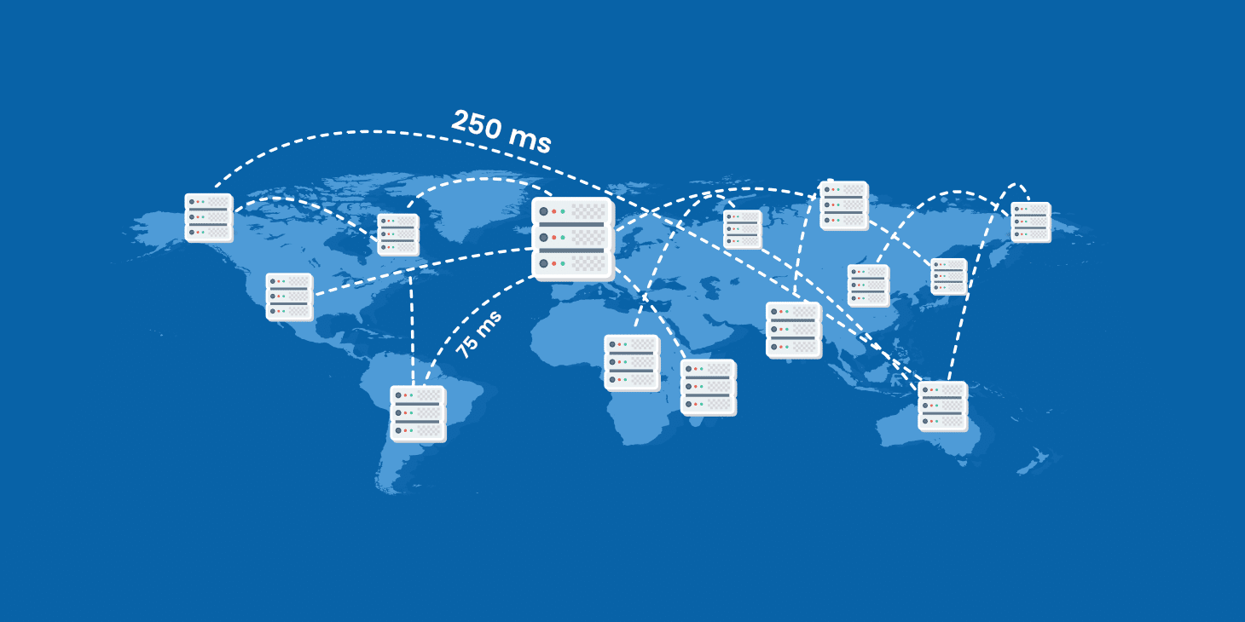
There are few different tools out there which you can utilize to compare latency between providers. CloudHarmony is one of which provides objective, impartial and reliable performance analysis to compare cloud services. They utilize a network of about 50 servers located throughout the world to periodically measure and record latency and throughput measurements to other clouds. We ran a test of both Google Compute Engine and AWS EC2 from our current location in the US.

Google Compute Engine (CloudHarmony Latency Test)
Compute Location | Fastest Latency | Median Latency | Slowest Latency
GCE (us-central1-c) | 77 ms | 85 ms | 381 ms
GCE (us-east4-a) | 77 ms | 79.5 ms | 105 ms
GCE (europe-west3-c) | 166 ms | 193.5 ms | 271 ms
GCE (asia-east1-b) | 154 ms | 172 ms | 212 ms
GCE (europe-west2-a) | 161 ms | 165 ms | 249 ms
GCE (us-west1-b) | 50 ms | 51 ms | 61 ms
GCE (asia-northeast1-b) | 128 ms | 139 ms | 194 ms
GCE (asia-southeast1-b) | 192 ms | 211.5 ms | 281 ms
GCE (europe-west1-c) | 162 ms | 179.5 ms | 251 ms
GCE (us-east1-c) | 91 ms | 109.5 ms | 221 ms
GCE (northamerica-northeast1-a) | 91 ms | 96.5 ms | 155 ms
GCE (australia-southeast1-a) | 163 ms | 165 ms | 464 ms
GCE (asia-south1-a) | 244 ms | 165 ms | 284 ms
GCE (southamerica-east1-a) | 196 ms | 198 ms | 228 ms
GCE (europe-north1-b) | 195 ms | 200.5 ms | 234 ms
GCE (europe-west4-b) | 166 ms | 169 ms | 233 ms

Updated July 2018, Source: CloudHarmony (running from USA ISP)

AWS EC2 (CloudHarmony Latency Test)
Compute Location | Fastest Latency | Median Latency | Slowest Latency
AWS EC2 (us-west-2) | 102 ms | 110.5 ms | 228 ms
AWS EC2 (us-east-2) | 161 ms | 200.5 ms | 232 ms
AWS EC2 (eu-central-1) | 333 ms | 343.5 ms | 382 ms
AWS EC2 (us-east-1) | 172 ms | 343.5 ms | 329 ms
AWS EC2 (ca-central-1) | 81 ms | 173.5 ms | 427 ms
AWS EC2 (eu-west-1) | 197 ms | 429 ms | 576 ms
AWS EC2 (eu-west-2) | 326 ms | 370.5 ms | 581 ms
AWS EC2 (us-west-1) | 66 ms | 72 ms | 128 ms
AWS EC2 (ap-northeast-1) | 155 ms | 295 ms | 517 ms
AWS EC2 (ap-south-1) | 251 ms | 395 ms | 562 ms
AWS EC2 (ap-southeast-2) | 197 ms | 450 ms | 604 ms
AWS EC2 (sa-east-1) | 384 ms | 397 ms | 408 ms
AWS EC2 (eu-west-3) | 311 ms | 329.5 ms | 401 ms
AWS EC2 (ap-southeast-1) | 404 ms | 431.5 ms | 449 ms
AWS EC2 (ap-northeast-2) | 319 ms | 336 ms | 574 ms

Based on the above comparisons GCP is more preferable . GCP is leading when we see pricing and speed.

https://www.zdnet.com/article/top-cloud-providers-2019-aws-microsoft-azure-google-cloud-ibm-makes-hybrid-move-salesforce-dominates-saas/.
https://aws.amazon.com/products/.
https://cloud.google.com/gcp/getting-started/.
https://aws.amazon.com/getting-started/tutorials/.
https://aws.amazon.com/migration-acceleration-program/.
https://azure.microsoft.com/en-us/blog/announcing-azure-cli-2-preview/.
Google Cloud vs AWS in 2019 (Comparing the Giants) by Brian Jackson available at https://kinsta.com/blog/google-cloud-vs-aws/ (Date accessed November 2, 2019).
https://kinsta.com/blog/google-cloud-vs-aws/.

